Exercise 4 – Implementing the Adapter Pattern

Scenario
Develop a payment processing system that integrates multiple third-party payment gateways using the Adapter Pattern.

Understanding the Adapter Pattern
The Adapter Pattern allows incompatible interfaces to work together by converting one interface into another expected by the client.

Project Name
AdapterPatternExample

Implementation
interface PaymentProcessor{
void processPayment(double amount);
}
class PayPalGateway{
void makePayment(double amount){
System.out.println("Processing payment using PayPal Gateway...");
}
}
class StripeGateway{
void pay(double amount){
System.out.println("Processing payment using Stripe Gateway...");
}
}
class PayPalAdapter implements PaymentProcessor{
private PayPalGateway gateway=new PayPalGateway();
public void processPayment(double amount){
gateway.makePayment(amount);
}
}
class StripeAdapter implements PaymentProcessor{
private StripeGateway gateway=new StripeGateway();
public void processPayment(double amount){
gateway.pay(amount);
}
}
public class AdapterTest{
public static void main(String[] args){
PaymentProcessor p1=new PayPalAdapter();
PaymentProcessor p2=new StripeAdapter();
p1.processPayment(5000);
p2.processPayment(3000);
System.out.println("\nPayments completed successfully using Adapter Pattern.");
}
}

Sample Output
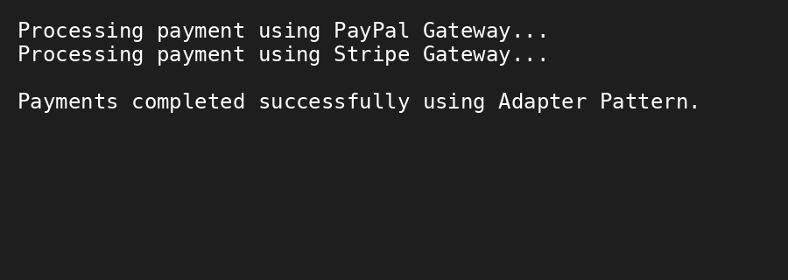

Conclusion
The Adapter Pattern enables different payment gateway interfaces to be used through a common interface, improving flexibility and integration.

